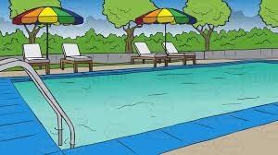

**Princess Anne Gardens Pool**

….**opens on Saturday May 29th at 12:00 noon and will be open 7 days a week from noon to 8PM, weather permitting**.

* The pool is open to all homeowners and renters, and guests accompanying them. You must present a pool pass to the attendant when you enter the pool. Renters should contact their landlord to obtain pool passes.
* **NO LIFEGUARD is present.** Swim at your own risk and provide supervision to all children under the age of 14. For children under 5, a parent or other adult must remain in the pool with the child.
* The attendant is present at all times the pool is open and is authorized to regulate pool use to maintain safety. The attendant is authorized to remove people from the pool area if necessary.
* Pool toys, rafts, noodles, etc. designed for pool use are permitted.
* Wet bathing suits are not allowed in the main clubhouse areas.
* Items prohibited in the pool area are pets, glass containers and alcoholic beverages.